**Business Requirement Specification:**

Customer Support

Version: 1.1

Responsibility Assignment (RACI)

|  |  |  |  |  |
| --- | --- | --- | --- | --- |
| **Sponsor\*** | **Business Analyst** | **IT Solution Analyst** | **UX Designer** | **IT Partner** |
| Accountable | Responsible | Consulted | Informed | Informed |
| Tim Ellmers | Shashi Shekhar | NA | Jyoti Gaonkar | Capgemini |

*Sponsor = Business representative, Web Area Manager, or Solution Area Manager

*Note: This RACI matrix is valid for this document only, not the entire CR.*

See the BA Guideline [5] for more information about responsibilities throughout the requirement analysis process.

Revision History

|  |  |  |  |
| --- | --- | --- | --- |
| **Date** | **Version** | **Description** | **Responsible** |
| 2016-04-01 | P1.0-1 | First outline of the document | Donna Stewart |
| 2016-04-18 | P1.0-2 | Clarify business needs and scope of the document | Donna Stewart |
| 2016-05-09 | P1.0-3 | Changing document scope to allow a holistic view | Tim Ellmers |
| 2016-05-20 | P1.0-4 | Changing document as per comments from Tim Ellmers | Shashi Shekhar |
| 2016-05-23 | P1.0-5 | Changing IRW (Mobile Web) requirements as per comments from Peter Rohman | Shashi Shekhar |
| 2016-05-25 | P1.0-6 | Changing NWP and IKEA Inside requirements as per comments from Andreas Järgren, Sakke Mustonen, Anders Jehander | Shashi Shekhar |
| 2016-05-31 | P1.0-7 | Changing Web Analytics requirement as per comments from Martin Oltegen | Shashi Shekhar |
| 2016-06-10 | P1.0-8 | Changing requirements for Business, IKEA IRW(FS & MW), INSIDE and NWP as per comments from stakeholders after requirement/solution kick –off meeting on 8th June 2016 | Shashi Shekhar |
| 2016-06-10 | P1.0-9 | Some updates reflecting the current situation and pre-discussion about possible options | Tim Ellmers |
| 2016-06-14 | P1.0-10 | Updating BRS based on comments from Andreas Järgren (dated: 14th Jun 2016) | Shashi Shekhar |
| 2016-06-20 | P1.0-11 | Updating BRS based on comments from Lars Troneby (dated: 16th Jun 2016) and Magnus Dahl (dated:17th Jun 2016) | Shashi Shekhar |
| 2016-06-27 | P1.0-12 | Updating BRS for Russia specific JST requirements | Shashi Shekhar |
| 2016-07-01 | P1.0-13 | Review and updates | Tim Ellmers |
| 2016-08-23 | P1.0-14 | Updating BRS for requirements changes under Change Requirements & Validations section 4 (4.1 & 4.2) | Shashi Shekhar |
|  |  |  |  |
|  | **1.1** | **BRS Approval** | **Tim Ellmers** |

Table of contents

Responsibility Assignment (RACI) 1

Revision History 2

Table of contents 3

1 Introduction 4

1.1 Purpose of the document 4

2 Update IKEA Jobs search to use IBM Kenexa Brassring API 5

2.1 Business Need 5

2.1.1 Agreed Solution (Microsite) Requirement Specifications 6

2.1.2 Russia JST Requirements 13

2.1.3 IRW (Full Site) Requirement Specifications 14

2.1.4 IRW (Mobile Web) Requirement Specifications 15

2.1.5 NWP (New Web Platform) - Requirement Specifications 15

2.1.6 IKEA INSIDE Requirement Specifications 16

2.1.7 Affected Business Capability 17

2.1.8 Business current state/solution 17

2.1.9 Business drivers 18

2.1.10 Measurable business goals 19

2.1.11 Business Future State/Wished business solution 19

2.2 Dependencies 20

2.3 Countries in scope 20

2.3.1 Not in scope 22

2.3.2 Pilot country 22

3 Client needs 23

4 Change Requirements & Validations 26

4.1 Change requirements 26

4.2 Validations 27

5 Non-functional requirements 28

6 Web Analytics requirements 30

6.1 Requirements 30

7 SEO (Search Engine Optimization) 30

7.1 Requirements 30

8 Security Standards 30

8.1 Requirements 30

9 Release Information 30

9.1 Wanted Release 30

10 Definitions, Acronyms, and Abbreviations 30

11 References 31

# Introduction

## Purpose of the document

This documents purpose is to understand what the business wants to do, why we want to do it and how the situation is today. This document contains all the information that expresses business goals and needs and the impact on the business solution(s), process(es), and organisation, within scope for a specific Change Request (CR).

## Business Need

* Replace the current IKEA job search tool on IKEA.com with a new and redesigned Job Search Tool to allow for a better candidate experience while searching and applying for a job. Applies to both internal (IKEA) and external candidates. Solution is global.
* Deliver the same new IKEA Job search tool solution to the following platforms;

1. IRW (FS) - using external TG’s
2. IRW (MW) - using external TG’s
3. New Web - using external TG’s
4. IKEA INSIDE. This uses Internal TG’s. This triggers different talent gateways to what external customers see.
5. ICO Worker – This uses Internal TG’s. This is an internal platform used by IKEA (share point technology)

* One solution needs to be developed and needs to fulfil the requirements of above mentioned platforms to be released afterwards.
* The solution shall work with all markets/ countries that use the IBM Kenexa Brassring solution today.
* All the functions of newly developed solution shall be displayed on any device. New developed solution shall support multi lingual feature with new and better selection criteria such as multi-selection, suggestive search and total job available result numbers.
* Standard requirements of infrastructure to be implemented. User experience/journey shall be consistent.
* Standard web analytics measurements to be considered for solution development. (refer section 5)
* Keyword search shall be added to the new solution.
* No specific requirement regarding page dimensions. Standard shall be followed.
* New solution shall have global content and search result page to be customized for SEO. (refer section 6)
* New solution shall be aligned to general security standards (refer section 7). Solution shall support latest two versions of global browsers with fast update pace such as Chrome and Firefox (both desktop and mobile versions apply). Solution shall support latest three versions of global browsers with slow update pace such as Safari, IE and Edge (both desktop and mobile versions apply). Solution shall support local/regional browsers that are very common in a specific market (Yandex in Russia) i.e. latest two versions shall be supported. The support is limited in the sense that “pixel perfect” is not required, however all functionality shall work.
* Solution architecture shall be adaptable to other Application Tracking Systems (ATS).

**Other Benefits**

* Better availability and usability of job search functionality for internal and external candidates.
* Easy maintenance of Job Search Tool values using API technology from ATS to the Job Search tool.
* Accessibility via mobile devices without losing functionality.

### Agreed Solution (Microsite) Requirement Specifications

* As agreed solution, a microsite needs to be developed which will host the developed solution Job Search Tool (JST). The microsite will be hosted as part of site extension under IKEA.com domain.
* Microsite hosting the new developed solution (JST) shall be designed in accordance with IKEA recruitment communication and visual communication guidelines.
* The new solution will use the IBM Kenexa brassring API.
* Newly developed microsite will have only global content on it.
* A customized header and footer with IKEA branding will be included in the microsite irrespective of header and footer style of IRW (FS & MW), NWP, IKEA INSIDE and ICO Worker. The header shall have only link – “WORKING AT THE IKEA GROUP” at the left justified below IKEA logo. The footer shall have “Cookie Policy” and “Terms of Use” right justified. Below it should be © Inter IKEA Systems B.V. 1999 – 2016 again right justified.
* Working at the IKEA group link shall direct to the Working at the IKEA group page of the Market using which Candidate reached the microsite.
* Customized job search result page will be displayed instead of As-Is situation where IBM Kenexa Brassring displays the result page in an iFrame.
* For the main JST iFrame will be avoided. For a better User Journey iFrame can be an option for related web pages coming from an ATS.
* All the countries and locations available in the ATS database shall be listed even though jobs are not available for those countries/locations. However, the job count can be shown as zero.
* Below are the screenshots of conceptualized wireframe of To-Be developed JST:

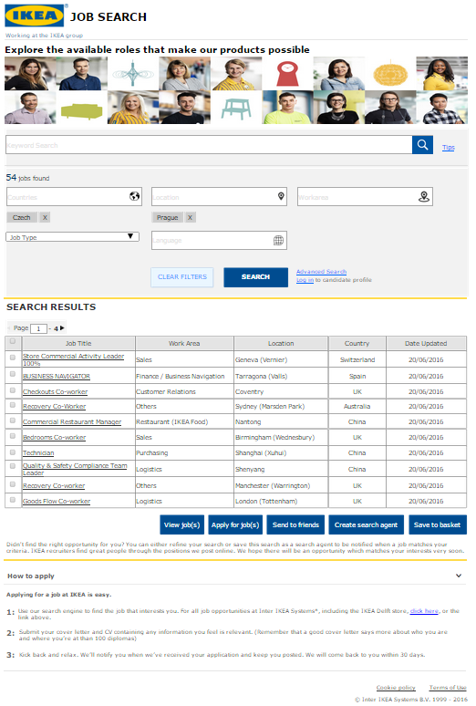

*Fig 1: Wireframe of To-Be developed Job Search Tool page along with search results*

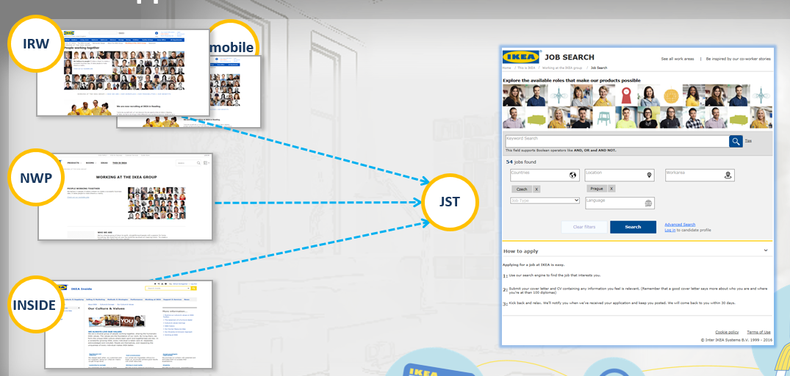

*Fig 2: All the platforms (IRW (FS & MW), NWP and IKEA INSIDE will have a link redirecting to the microsite*

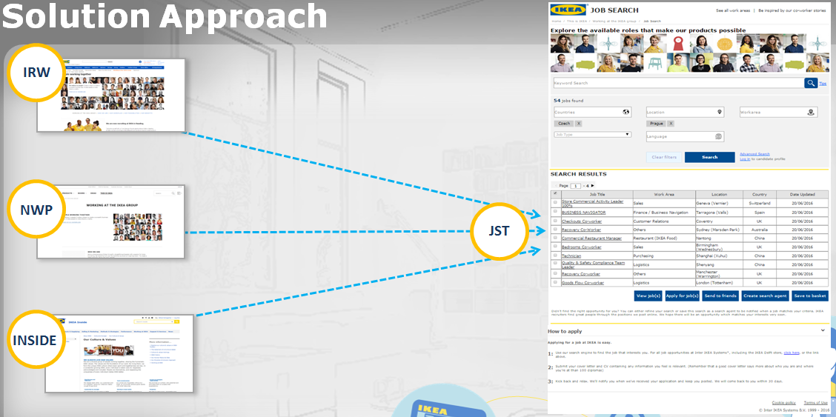

*Fig 3: Search results will be displayed on the same page as new developed job search tool*

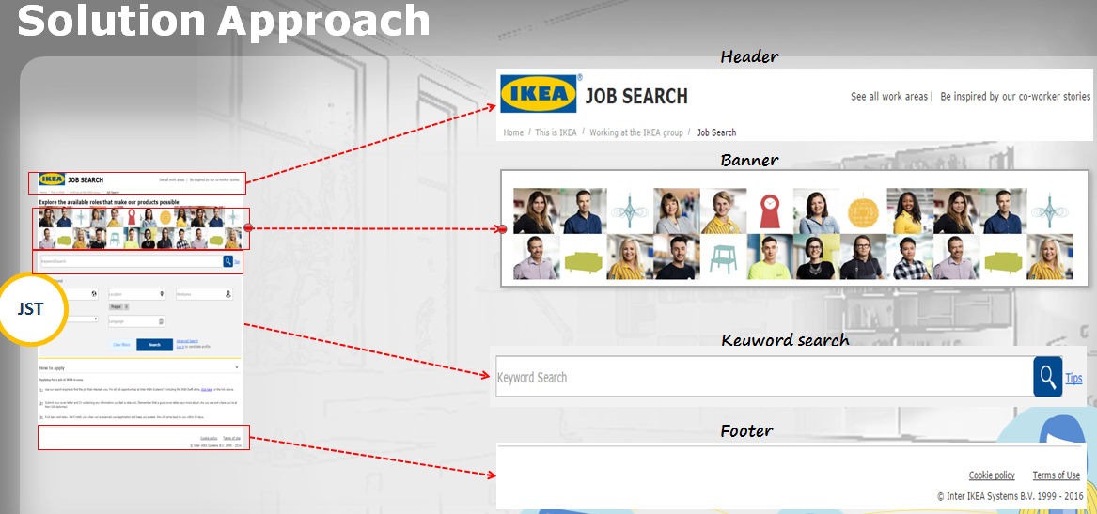

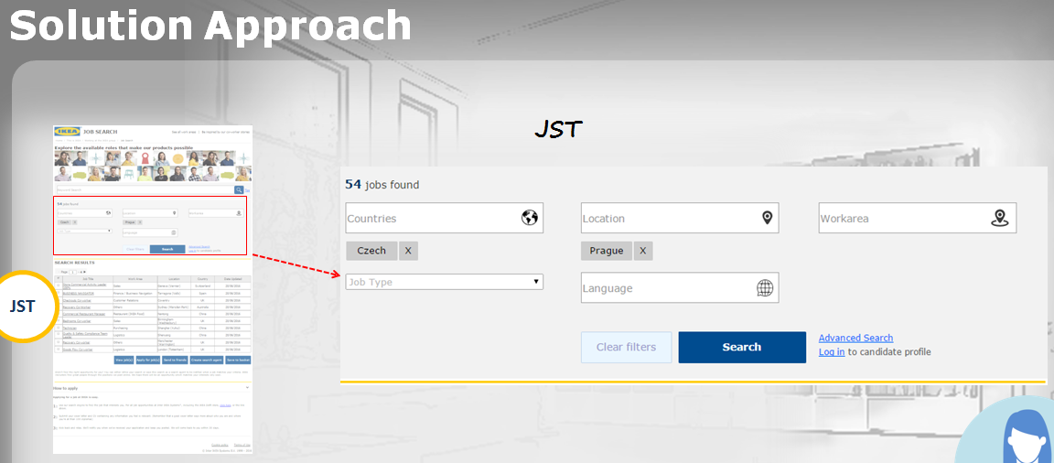

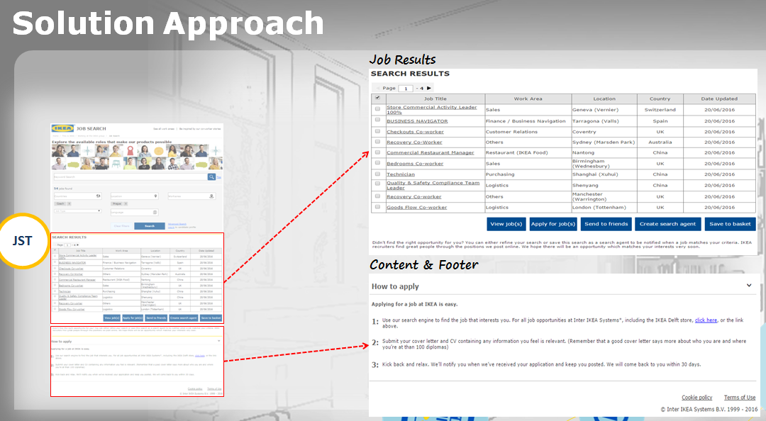

*Fig 4,5,6: Wireframes of elements of Microsite with enlarged view*

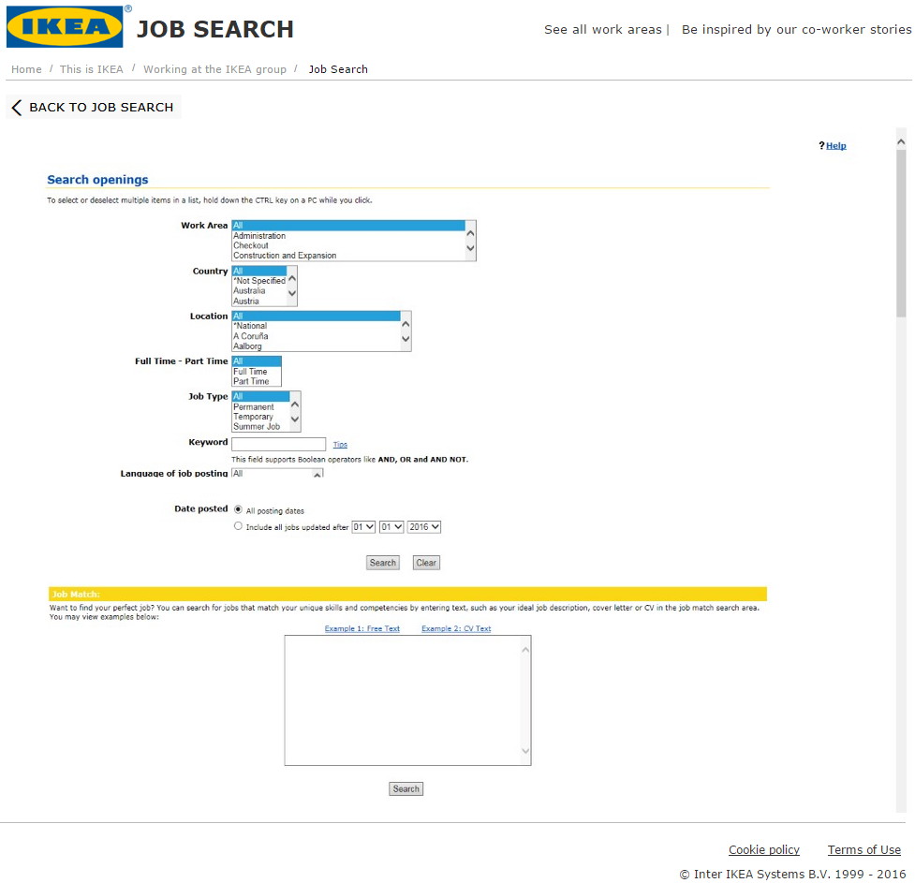

*Fig 7: Wireframe of advanced search page*

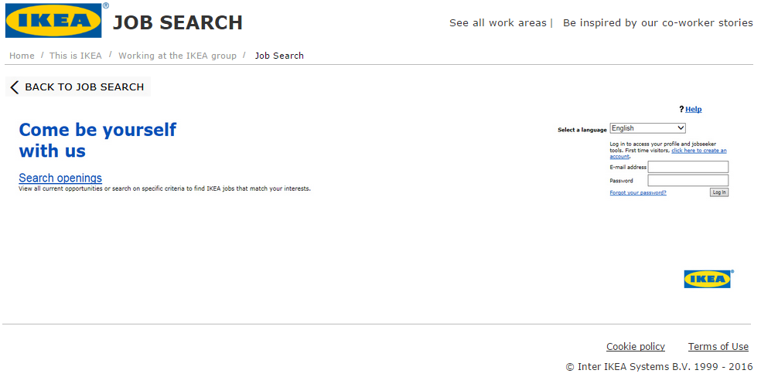

*Fig 8: Wireframe of login page (including old elements that need to be removed via CR against Kenexa)*

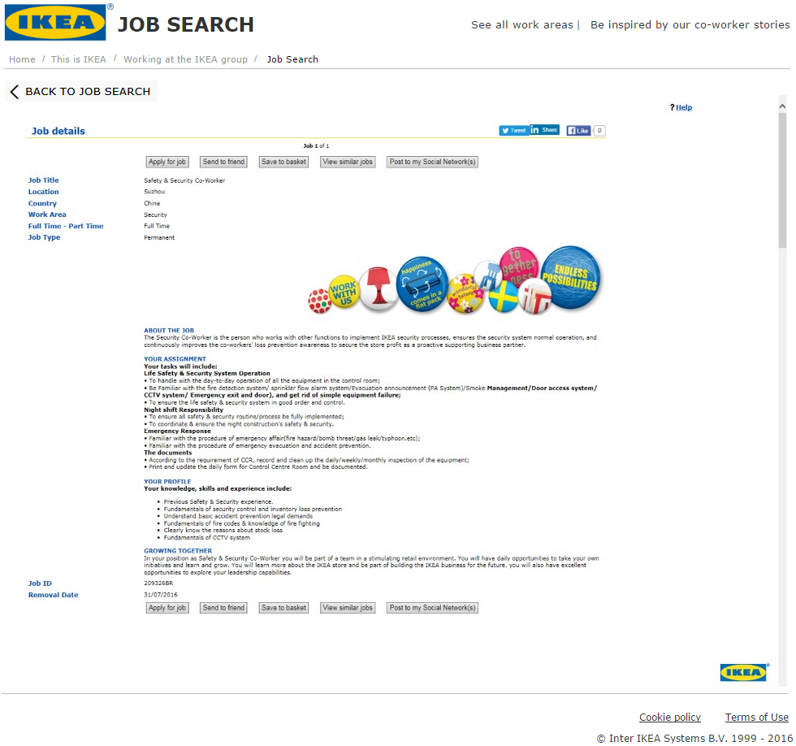

*Fig 9: Wireframe of job description page*

* Release of the micro site to all the platforms i.e. IRW (FS & MW), NWP, IKEA Inside and ICO worker is in-scope. All the platforms, IRW (FS & MW), NWP and IKEA INSIDE will have a link redirecting to the micro site.
* **Job Search result page requirement specifications**
  + ‘Back to Jobs search’ link shall be displayed if the job search results are being displayed in a separate page. If the job search results are bring displayed in the same page then the link shouldn’t be displayed.
  + Requirement flow consisting of three steps i.e. **Log in** -> **Search openings** -> **Search results** shouldn’t be displayed on job search results page.
  + ‘Refine Search Criteria’ shall be displayed, if job search results are being displayed on separate page. If the job search results are being displayed in the same page then the link shouldn’t be displayed.
  + Scrolling shall be avoided while displaying job search results. Maximum 50 results per page can be displayed. Based on the user experience, number of results to be displayed per page shall be decided. Whether the job search result are shown in same page or new page, number of job search result shown may vary accordingly.
  + Job selection buttons i.e. View jobs, Apply for jobs, Send to friends, create search agent, save to basket shall remain As-Is. Developed solution shall consider the Russia legal requirements and shall be able to handle it.
  + The selection buttons need to be displayed on top and bottom of job search result page grid if the results are being displayed in separate page. If the results are being displayed in same page, then selection buttons preferably shall be on top. It shall be decided considering user experience.
  + Job search result grid column headers i.e. Job Title, Work Area, Location, Country, Date updated should remain As-Is. Include a grouping filter during job search result display.
  + Row and column header check box option to select job(s) from result page shall remain As-Is. ‘Click ticked’ option shall also remain As-Is.
  + Job title shall have links like As-Is solution.
  + Page selection (Pagination) will be displayed
  + Text at the bottom of jobs result page of As-Is IBM Kenexa Brassring page i.e. ‘*Didn’t find the right opportunity for you? You can either refine your search or save this search as a search agent to be notified when a job matches your criteria. IKEA recruiters find great people through the positions we post online. We hope there will be an opportunity which matches your interests very soon.’*  shall be displayed on every job search.
  + In case of no search result, text to be displayed – ‘*Your search returned 0 matches. You can either* [*refine your search*](https://sjobs.brassring.com/2057/asp/tg/cim_advsearch.asp?SID=%5eHF8KAxREl0nihRVcVKWgVGn1lpZKoBwnF_slp_rhc_hFEBgXjR4/p3R9QNEJKuKLisEOg332) *or* [*save this search as a search agent*](javascript:openWindow3('cim_pop_savesearch.asp?SID=%5eHF8KAxREl0nihRVcVKWgVGn1lpZKoBwnF_slp_rhc_hFEBgXjR4/p3R9QNEJKuKLisEOg332');) *to be notified when a job matches your criteria.***’** Only display “Create search agent” button shall be shown and not the other buttons.
  + Hover Text as shown below shall be displayed As-Is when you hover the cursor over Job title and Hover text is available for the job description.

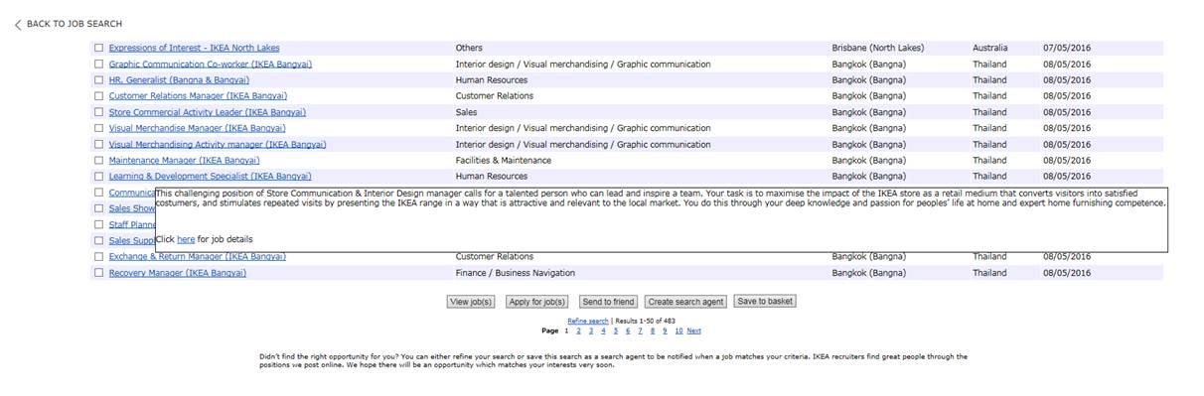

* The left navigation of the new microsite bar shall be removed and the links inside left navigation shall be moved to header after discussing the need.
* Banner from [HR communcation](http://preview.ikea.com/ms/en_SE/this-is-ikea/available-jobs/index.html) shall be displayed as banner in new job search tool (banner mentioned in <http://preview.ikea.com/ms/en_SE/this-is-ikea/available-jobs/index.html>)
* Translation of microsite page and labels and values of JST to the specific languages mentioned in section 2.3.
* Login to candidate profile link and Advanced search link from Kenexa shall be displayed on new developed solution search criteria input page. Both the pages will have the new microsite header and footer with iFrame content of existing As-Is advanced search and login to candidate profile pages.

### Russia JST Requirements

* A Russian candidate shall be able to create login or store his personal details (in any scenario) only in AVNET tool for now (as per Russia regulations).
* If the user is coming from Russian webpage / landing page to the microsite, the microsite must be intelligent enough to hide advanced search and candidate login links from job search tool.
* Job results page shall have jobs listed for locations within and outside Russia.
* If candidate is coming from Russian webpage / landing page to the new microsite (job result page), the buttons i.e. Create search agent and Save to Basket shall be hidden. In case, a non-Russian job is selected to be applied by candidate, then the above mentioned buttons should be displayed.
* On job search result list page, if the user selects multiple jobs to apply which consists of Russian (job location is in Russia) and Non-Russian (job location is outside Russia) jobs, then an error message should be displayed like ‘the candidate can’t apply to Russian and Non-Russian job together’. The final wording needs to be discussed in project.
* Questionnaire for Russian job location shall not be translated to other languages than the existing owns. Every candidate applying for a Russian job must answer the questionnaire.

### IRW (Full Site) Requirement Specifications

* Replacement of current IKEA Job Search module on IRW sites with a newly designed and integrated job search tool using IBM Kenexa Brassring API(s).(Removal and clean-up of existing Job Search Pages are not in scope).
* Update UI, GUI and visual changes to the search tool - such as
* Changing the order of drop lists
* General styling improvements
* Create new interactions when searching for jobs such as multi-select of some search criteria, display the total number of jobs searched, reset filters and other new IRW functionality seen by IKEA customers.
* Good to have the JST and results on the same page for better user experience. No specific requirement regarding page dimensions. Standard shall be followed.
* Avoid iFrame during solution development.
* New solution shall have global content and search result page to be customized for SEO. (refer section 6)
* The same jobs search module is reused in multiple pages on IRW today. Updates to these web pages shall be done in all instances.(out of scope for this development project)
* Standard web analytics measurements to be considered for solution development (refer section 5). Also, the new solution shall be able to implement universal Telium code on all in-scope new JST pages so we can stitch together the user behaviour from both IRW and the new solution.
* New solution shall be aligned to general security (refer section 7) and performance standards. New developed solution shall be designed in order to have low maintenance after deployed to production. Especially when it comes to display selection values like Countries and locations that change frequently.
* Accessibility level shall be ‘AA’ compliant.

Example of IKEA Jobs pages in a local site:

* [*http://www.ikea.com/ms/en_GB/this-is-ikea/available-jobs/index.html*](http://www.ikea.com/ms/en_GB/this-is-ikea/available-jobs/index.html)
* [*http://www.ikea.com/ms/en_GB/about-the-ikea-group/available-jobs/index.html*](http://www.ikea.com/ms/en_GB/about-the-ikea-group/available-jobs/index.html)

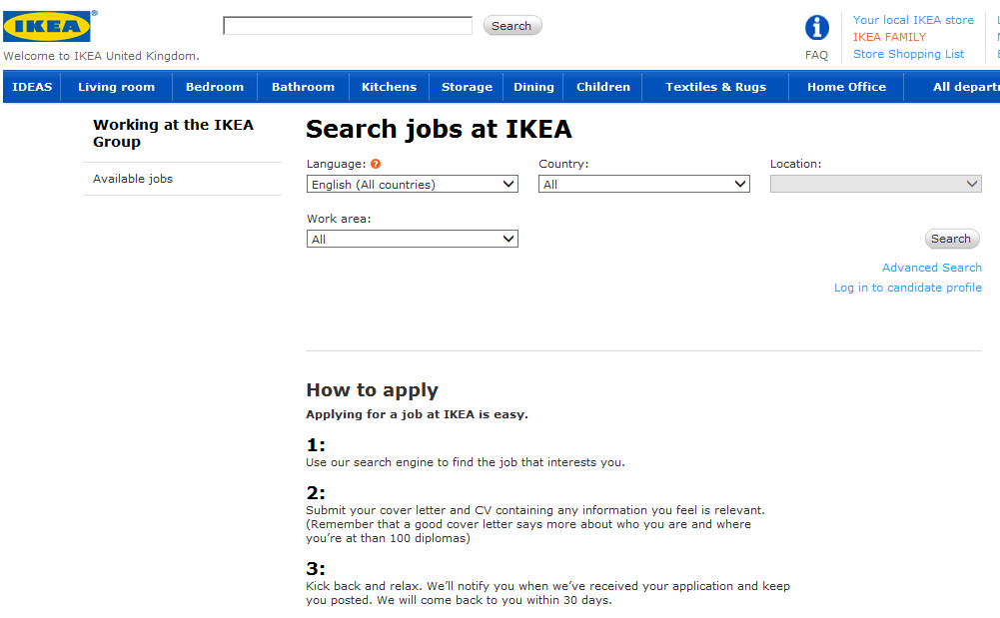

### IRW (Mobile Web) Requirement Specifications

* In general, iFrame solution shall be avoided.
* New developed solution shall portray IKEA look and feel such as input page shall have similar fonts size and colour as IKEA site.
* Inline and Instant validation shall be part of the solution. Suggestion is to have a config file at the backend rather than hard coded validation in code.
* Development of UI shall be as per font style, font size, input fields, dropdowns, buttons, text fields, touch sensitivity as mentioned in the UI development guidelines for IKEA sites.
* Standard web analytics measurements to be considered for solution development. (refer section 5)
* Responsiveness shall be handled by the new developed solution.
* New solution shall have global content and search result page to be customized for SEO. (refer section 6)
* NO need to use the IRW IKEA Header / Footer. It is fine to imitate the look and feel based on IKEA style standards.
* Standard requirements of infrastructure to be implemented. New solution shall be aligned to general security (refer section 7) and performance standards. New developed solution shall be designed in order to have low maintenance after deployed to production
* At least WCAG level ‘A’ compliance shall be there for new solution.

### NWP (New Web Platform) - Requirement Specifications

* New solution shall be made as much responsive as possible.
* New solution shall work with URL link along with standard requirements of infrastructure.
* New solution input field data shall be taken from backend so that free text validation can be avoided.
* New developed solution shouldn’t be using iFrame solution as it affects the web analytics of the site. NWP has no control over web analytics of the response from IBM Kenexa Brassring API.
* IBM Kenexa Brassring API response within iFrame is not responsive in nature and scrolling at job result page affects the user experience in negative manner. New developed solution shall be able to handle it.
* Standard web analytics measurements to be considered for solution development. (refer section 5)
* New solution shall be aligned to general security (refer section 7) and performance standards. New developed solution shall be designed in order to have low maintenance after deployed to production.
* Accessibility level shall be ‘AA’ compliant. New solution shall have global content and search result page to be customized for SEO. (refer section 6).

### IKEA INSIDE Requirement Specifications

* The list of languages seen on Inside job vacancy portal shall be replaced with the URL redirected to the new designed Job Search solution - <https://inside.ikea.com/careerlearning/JobVacancies/Pages/default.aspx>

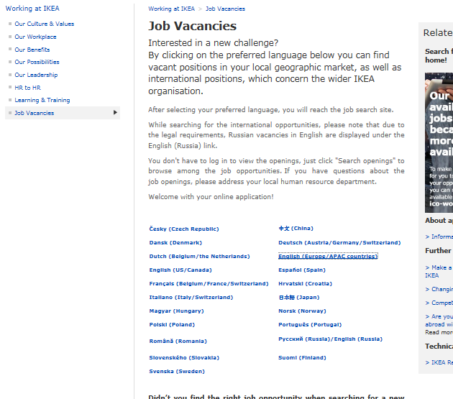

* The new designed and developed tool URL shall end with **ikea.com** and shall be **SSL enabled**. New solution shall also follow standard requirements of infrastructure and security (refer section 7).
* Internal employee shall be able to see Jobs posted to the Internal Gateway
* No specific requirement on the look and feel of the new developed solution. The new solution shall be responsive in nature.
* New developed solution URL shall be placed in middle column (width: 560px). The new developed solution URL shall be accessible from ICN.
* New solution shall be aligned to general performance standards. New developed solution shall be designed in order to have low maintenance after deployed to production.
* Accessibility level shall be ‘AA’ compliant.

### Affected Business Capability

Customer Support

### Business current state/solution

Today in IRW the IKEA Jobs search page uses a custom solution to present dropdown options for searching all IKEA jobs, globally. The current functionality is difficult to update or change easily.

* **Sub issue 1**: Current improved job search selection functionality is not available for internal candidates (IKEA INSIDE).
* **Sub issue 2**: Incorrect entries through lack of interface between Kenexa and Job Search module. High manual maintenance effort on IRW, NWP and IBM.
* **Sub issue 3**: Job search functionality has language as first selection criteria and that needs to be changed to country as first selection criteria to allow a satisfying candidate experience. Moreover a suggestive search result in dropdown lists and a display of search results are requested enhancements.
* **Sub issue 4**: Not all countries are connected to the Job Search Tool on IKEA.com (for example, Russia) due to failure to integrate newly created Russian TG with a Job Search Tool.
* **Sub issue 5**: The current job search tool does not allow to switch on the WCAG technology for the responsive design candidate experience within IBM Kenexa Brassring. This is preventing solution enhancement.

**IKEA Jobs pages in a local site examples are:**

* **Working at IKEA Entry point**: <http://www.ikea.com/ms/en_GB/this-is-ikea/working-at-the-ikea-group/index.html>
* **Jobs Landing 1**: <http://www.ikea.com/ms/en_GB/this-is-ikea/available-jobs/index.html>
* **Jobs Landing 2**: <http://www.ikea.com/ms/en_GB/about-the-ikea-group/available-jobs/index.html>
* **Back to Search CTA -** when in **sjobs.brassring pages** *(as currently iframe solutions)*

**sjobs.brassring pages** *(as currently iframe solutions)*

* **Results page:** <http://www.ikea.com/webapp/wcs/stores/servlet/IrwJobSearch>
* **Advanced search**: <http://www.ikea.com/webapp/wcs/stores/servlet/IrwJobSearch?storeId=7&langId=-20&target_page=advanced_search&returnURL=/ms/en_GB/this-is-ikea/available-jobs/index.html>
* **Log in to Candidate profile:** <http://www.ikea.com/webapp/wcs/stores/servlet/IrwJobSearch?storeId=7&langId=-20&target_page=login&returnURL=/ms/en_GB/this-is-ikea/available-jobs/index.html>
* **Login to jobs (not IRW, it is IBM Kenexa Brassring):** <http://www.ikea.com/webapp/wcs/stores/servlet/IrwJobSearch>
* **Sign up  to jobs (not IRW, it IBM Kenexa Brassring):** <http://www.ikea.com/webapp/wcs/stores/servlet/IrwJobSearch>
* **Help -** <https://sjobs.brassring.com/2057/asp/tg/help/TG_help.asp?&type=help#cim_advsearch_help>
* **Create an account** [https://sjobs.brassring.com/2057/asp/tg/cim_pop_privacypolicy.asp?PS=1&RegType=Lite_Home&ref=428201645833&SID=^p7nVtozU6/3ZDj7YndnRNmXr84BxtyOyVZE9DsYhhmLsyw7xuJ9uHJsP768Q7atY](https://sjobs.brassring.com/2057/asp/tg/cim_pop_privacypolicy.asp?PS=1&RegType=Lite_Home&ref=428201645833&SID=%5ep7nVtozU6/3ZDj7YndnRNmXr84BxtyOyVZE9DsYhhmLsyw7xuJ9uHJsP768Q7atY)
* **Forgot password** - [https://sjobs.brassring.com/2057/asp/tg/pds_pop_lostpassword.asp?SID=^p7nVtozU6/3ZDj7YndnRNmXr84BxtyOyVZE9DsYhhmLsyw7xuJ9uHJsP768Q7atY](https://sjobs.brassring.com/2057/asp/tg/pds_pop_lostpassword.asp?SID=%5ep7nVtozU6/3ZDj7YndnRNmXr84BxtyOyVZE9DsYhhmLsyw7xuJ9uHJsP768Q7atY)

### Business drivers

|  |  |
| --- | --- |
| **Business Driver** | **Explanation** |
| Improved user experience | To allow for a better candidate experience while searching and applying for a job. Availability and usability of job search functionality for internal and external candidates. |
| Maintenance | Easy (automatic) maintenance of Job Search Tool using interface (API) technology from ATS to the Job Search tool. |
| Mobile accessibility | Accessibility via mobile devices without losing functionality |
| Multiple ATS Instance connection | Designed to be connected to other Instances of the same ATSs in one Job Search tool. (design should be open for possible new ATSs) |
| Use of solution for internal candidates | To add (the same) job search tool at ikea.inside or New Web  IKEA INSIDE shall be brought in alignment to the new developed solution. |
| Reduction in Service Requests | Reduce the number of tickets reported to zero |
| Timely updates | Less than 1 hrs after changes has been made in the IBM Kenexa Brassring database.  Manual updates shall be avoided. |
| Fix Russian JST solution | Provide Russia with customized Job search tool solution |

### Measurable business goals

|  |  |
| --- | --- |
| **Business Goals** | **Measure** |
| Reduction in Service Requests | Reduce the number of tickets reported to zero |
| Timely updates | Less than 1 hrs after changes has been made in the IBM Kenexa Brassring database. |

### Business Future State/Wished business solution

We need to:

1. Redesign how these dropdown values are served and update the IKEA Jobs search to use a IBM Kenexa Brassring API instead of a custom IRW solution.
2. Update all the dropdown values to be fetched from IBM Kenexa Brassring API.
   1. Change the display & order of the search criteria ///Display the filter criteria of the search (candidate can always change the filter criteria) (Example from Benteler careerpage)
   2. Real time automatic synchronization of jobs and all search criteria (language, location, org unit, etc.) between ATS database or internal caching and new Job Search tool.
   3. New developed solution shall be smart enough to limit the input options of a filter based on the values selected for previous filter (for example: If the user selects Sweden and Finland as input for Country filter, the location filter shall have values from country Sweden and Finland and so on for other filters.)
   4. Possibility to have specified filters available on a Job Search Tool and in the following order of display:
      * Country
      * Location
      * Work area
      * Part time/full time
      * Language
   5. Possibility to have keyword searches with filter limitation to give better user experience to candidates.
   6. All filters can be selected separately without following an order.
   7. Display number of found jobs per selection (see picture F7) once a criteria was selected
   8. Reset filter in different sub categories (see picture F10)
   9. Possibility to have a suggestive search (when a candidate starts typing a combination of letters possible suggestions appear).
   10. Possibility to get results in the keyword field regardless the language of query
   11. The display of job results list can be via a newly developed Result List that is shown on IKEA side and not linking to Kenexa.
   12. The real application will be done via and in IBM Kenexa Brassring.

Other Links stay the same on pages e.g. Log in to candidate profile and advanced search Difference for the RU solution where is shall be prevented that user from RU gateway are able to use, see or log into the Kenexa Log In pag**e**.

**Licensing**

There are no licensing constraints when it comes to using the IBM Kenexa Brassring API. No further costs, it can be a constant interface. Requests can be hourly or on demand -depends on the solution we are building.

**IBM Kenexa Brassring URL changes**

There will be no URL changes needed based on the changes needed for this CR. Existing IRW URLs will remain unchanged.

The only thing to mention is that IF we move to the Responsive Design gateways the gateway URL's are different however any existing links will be redirected to the amended URL's. (Alan Hirth- IBM)

**Decommission of the current Jobs solution**

It is planned to decommission the old Job Search tool after all markets have gone live with the new tool.

**Supporting API documentation**

IBM Kenexa Brassring API documentation – See [6]

## Dependencies

## Countries in scope

* Refer to the below mentioned Market list. Need to have job search tool translated for labels, dropdown values and any global content in the following languages:

|  |  |
| --- | --- |
| **Market Name** | **Language** |
| Belgium | Dutch (NL) |
|  | French (FR) |
| Czech Republic | Czech |
| Denmark | Danish |
| Germany | German |
| Ireland | English |
| Spain | Spanish (ES) |
|  | Catalan (CA) |
|  | Euskera (EU) |
| France | French (FR) |
| Croatia | Croatian |
| Italy | Italian (IT) |
| Hungary | Hungarian |
| Netherland | Dutch (NL) |
| Norway | Norwegian |
| Austria | German |
| Poland | Polish |
| Portugal | Portuguese |
| Romania | Romanian |
| Russia | Russian |
| Switzerland | Deutsch (DE) |
|  | French (FR) |
|  | Italian (IT) |
| Slovakia | Slovak |
| Serbia (part of market expansion plan) | Serbian |
| Finland | Finnish |
| Sweden | Swedish(SV) |
| United Kingdom | English |
| Canada | English |
|  | French (FR) |
| United States | English |
| Australia | English |
| China | English |
|  | Chinese |
| India (part of market expansion plan) | English |
| Japan | English |
|  | Japanese |
| Malaysia | English |
|  | Malaysian |
| Singapore | English |
| South Korea | English |
|  | Korean |
| Thailand | Thai |
|  | English |

* Russia in-scope for the new solution. The new solution shall be customized in order to align with Russia’s legal requirements.
* USA, India and Serbia are in-scope for the new solution package.

### Not in scope

* A login profile to view the listed jobs which is different from IBM Kenexa Brassring APIs candidate login functionality.
* Setup any relevant redirects from retired/disconnected IRW, NW, INSIDE pages to point to the new location.
* Removal and clean-up of the current Job Search solution is out of scope for the development and this project.

### Pilot country

No pilot required / not part of the development project

# Client needs

|  |  |
| --- | --- |
| F2 | Possibility to have Job Search Tool designed in responsive design |
| F3 | Full functionality available using mobile devices and different browser |
| F4a | Possibility to choose which talent gateway from Kenexa (or any other ATS) is feeding to job search tool |
| F5 | Possibility to interface more than one ATS instance with a new Job Search Tool |
| F4 | Real time automatic synchronization of jobs and all search criteria (language, location, org unit, etc.) between ATS and new Job Search tool. |
| F6 | New developed solution shall be smart enough to limit the input options of a filter based on the values selected for previous filter (for example: If the user selects Sweden and Finland as input for Country filter, the location filter shall have values from country Sweden and Finland) |
| F7 | Possibility to have specified filters available on a Job Search Tool and in the following order of display:   * Country * Location * Work area * Part time/full time * Language   Possibility to have keyword searches with filter limitation to give better user experience to candidates.  All filters can be selected separately without following an order.  Example: from Benteler careerpage |
| F8 | Display number of found jobs per selection (see picture F7) once a criteria was selected. All the countries and locations shall be listed even though jobs are not available for those countries/locations. However, the job count can be shown as zero. |
| F9 | Reset filter in different sub categories (see picture F10) |
| F9a | Display the filter criteria of the search (candidate can always change the filter criteria) |
| F10 | After clicking ‘show jobs’ candidates shall get a result list of job listed based on the filters set before. Example: from Benteler careerpage |
| F10a | A "reset all" functionality shall be included. See picture above. |
| F11 | Possibility to have a suggestive search (when a candidate starts typing a combination of letters possible suggestions appear). |
| F12 | Possibility to get results in the keyword field regardless the language of query |
| F13 | Possibility to have job search tool translated for label and values in the following languages:   |  | | --- | | Catalan (CA) | | Chinese | | Croatian | | Czech | | Danish | | Deutsch (DE) | | Dutch (NL) | | English | | Euskera (EU) | | Finnish | | French (FR) | | German | | Hungarian | | Italian (IT) | | Japanese | | Korean | | Malaysian | | Norwegian | | Polish | | Portuguese | | Romanian | | Russian | | Serbian | | Slovak | | Spanish (ES) | | Swedish(SV) | | Thai | |
| F14 | Content of job search tool on IKEA.com shall connect to selected external Talent Gateway TG (jobs). Job Search tool on IKEA inside shall connect to selected internal TG. Thus different jobs shall be shown in different places. |

# Change Requirements & Validations

## Change requirements

* All the requirements regarding keyword search functionality shall change as mentioned under change requirements section 4.1.
* Keyword search and filter search functionality shall be merged instead of keeping two independent streams. This shall help user to filter down the jobs option.
* User shall see the jobs results count changing, when user has completed the input for keyword search and focus has moved away from the keyword search box. This is in addition to the existing functionality where the jobs results count is updated when a user does a selection from the other filters.
* Keyword search input shall not be case sensitive.
* Keyword search logic shall work on Job title, Country, Location, Workarea, Language, Job Type and Job description. For example, User gives input as ‘manager Helsingborg Sweden’; entered input will be searched in Job Title, Location, Workarea, Language, Job Type, Job description fields as ‘manager’ or ’Helsingborg’ or ’Sweden’.
* Search filters shall be applied on the results returned by keyword search logic. For example, user gives input as ‘manager system’ in keyword search, selects ‘Sweden’ as country search filter and clicks on search. Search filter ‘Sweden’ will be applied on the jobs returned by keyword search logic.
* As user gives input in double quotes for keyword search for example “system developer”. All the jobs containing these exact words – “system developer” will be displayed as search results.
* Keyword search functionality shall not support Boolean logic (AND, OR, etc. operators) such as in the case of IBM Kenexa brassring keyword search.
* Keyword search shall not support use of special characters for keyword search
* On clicking the **Tips** URL of Keyword Search Functionality, a modal pop up window should open which has a description on how to use keyword search functionality. This description content will be provided by IKEA.
* Hover text functionality shall be replaced with a click action on Job Title of entries displayed in search results. On clicking the Job Title link, an intermediate modal pop up window (like Tips pop up window) will open which has a small description of the job as content, ‘continue’ and ‘close’ buttons. On clicking the ‘close’ button at the bottom, the modal pop window shall get closed. On clicking the continue button, user shall be navigated to the job description page of IBM Kenexa Brassring which opens in the same tab.
* Action button i.e. ‘View Job(s)’ in search result section shall perform the functionality as mentioned below:

View Job(s): When user selects multiple jobs in search results and click on View Job(s) button, a modal pop up window shall be displayed as shown below:

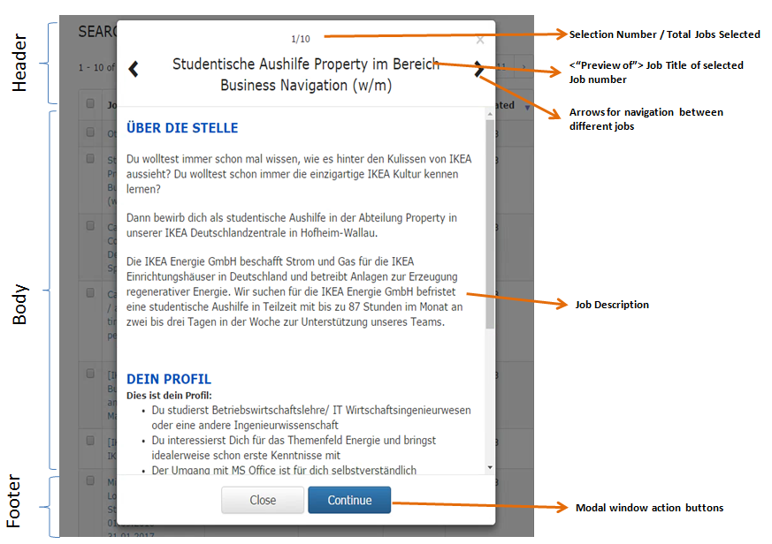

Header of Modal pop up window consists of:

* Selection Number / Total jobs selected
* Title : “Preview of Job Title” of selected job number
* Arrows on both sides of Job title for navigation among job titles

Body of Modal pop up window consists of:

* Job Description

Footer of Modal pop up window consists of:

* “Close” and “Continue” button: On clicking “Close” button will close the modal pop up window and on clicking “Continue” button window will take the user to full job description page of IBM Kenexa brassring.

However, other action buttons i.e. ‘Apply Job(s)’,’ Create search agent’, ’Send to friend’ and ‘Save to basket’ shall be implemented in next phase of the project. These buttons are still under discussion with IKEA and IBM.

## Validations

* All the input fields should have maximum input of 100.
* No validations if user doesn’t select any search criteria and clicks on the search button. In case of such an event, all the Jobs results must be displayed.
* A message translated as per the locale to be displayed, if search query doesn’t return any search result.
* User should be shown an appropriate error or exception message as the relevant event occurs such as network/application/server/database related error or exception events.
* User should be shown an alert message when user clicks on any of the following action buttons: view jobs, apply to jobs, send to friend, save to basket without selecting a job.
* Whenever a user selects a Russian and non-Russian job together, user should be shown an alert message to inform the user that a Russian job and a non-Russian job cannot be selected together to perform any operations on the job selection.
* User shall be informed of the cookies being used via a notification message.

# Non-functional requirements

|  |  |  |
| --- | --- | --- |
| **ID** | **Non-Functional Requirements** | **Acceptance Criteria** |
| NF1 | Infrastructure | Applying IKEA Standards : Job search tool is designed in accordance with IKEA visual communication guidelines (will be released in CW 10)  Solution shall support latest two versions of global browsers with fast update pace such as Chrome and Firefox (both desktop and mobile versions apply). Solution shall support latest three versions of global browsers with slow update pace such as Safari, IE and Edge (both desktop and mobile versions apply). Solution shall support local/regional browsers that are very common in a specific market (Yandex in Russia) i.e. latest two versions shall be supported. The support is limited in the sense that “pixel perfect” is not required, however all functionality shall work. |
| NF2 | Integration | A smooth integration without any UI weaknesses |
| NF3 | Security | New solution MUST be secure since it contains PII (personal identifiable information) data. Intrusion or leakage of such data could mean major damage to IKEA and cannot be accepted. SSL enabled and within ikea.com domain. |
| NF4 | Performance | |  |  | | --- | --- | | **Use Case** | **Response Time (in msec)** | | Search page loading with all dropdown values |  | | Update Total Job count in search page when criteria changes |  | | Search Jobs without any filter criteria. |  | | Search Jobs with Multiple filter criteria. |  | | Keyword search. |  | | Clicking Next page in Job Results. |  |   *(****Above figures on response time have to be discussed/decided w.r.t UI mock-ups of the new solution i.e. microsite – Magnus Dahl will support in deciding those figures.****)*  Given values are in *ms* and as the value measure in the end user browser at 95-percentile. This means 5% of the requests are slower, but 95% are faster than above figures. The technology for measuring this is RUM (Real User Measuring) – so the numbers include server time, network transport time and rendering in the browser. These performance parameters shall be acceptable from User Experience and tested in UAT/ BAT |
| NF5 | Availability | External availability shall be 99.82% best 18 hours and 99,5% rest of the time. All numbers apply for each market. Internal (tools) availability shall be 99.5% for the best 12 hours for each market. |
| NF6 | Capacity | System shall be able to search all the job opportunities uploaded to IBM Kenexa for IKEA markets. |
| NF7 | Cookie setting | **Avoid cookie setting** |

# Web Analytics requirements

## Requirements

From web analytics perspective, listed below parameters need to be measured.

* Standard measurement parameter(s): Number of users visiting the job search page and search result
* Recommended measurement parameter(s): View the most popular jobs, Order of events in a job search visit, Page referral i.e. the way a user navigates to job search page

# SEO (Search Engine Optimization)

## Requirements

* Standard SEO capabilities like editable page title, metadata, URL, headings and content shall be part of new solution.
* Links to the news solution page shall lead to ikea.com/nn/nn/, not away from ikea.com

# Security Standards

## Requirements

* The new solution MUST be secure since it contains PII (personal identifiable information) data. Intrusion or leakage of such data could mean major damage to IKEA and cannot be accepted.

# Release Information

## Wanted Release

Development delivery / release is planned for first week of September wk 37.

Our release doesn’t have dependency to other platforms like IRW, NWP and INSIDE. Releases of Job Search Tool to the platforms will be done by every platform based on their release process.

# Definitions, Acronyms, and Abbreviations

|  |  |
| --- | --- |
| **Term** | **Description** |
|  | |
| IBM Kenexa Brassring | It is an IBM tool whose API is used by the new designed and developed solution |
| Job Search tool (JST) | It is talent gateway for external and internal candidate to view internal and external job offers. |
| IRW | IKEA Retail Web |
| IRW (FS) | IRW (Full Site) |
| IRW (MW) | IRW (Mobile Web) |
| INSIDE | Intranet portal for IKEA employees |
| NWP | New Web Portal |
| TG | Talent Gateways |
| ATS | Applicant Tracking Systems |

Terminology not listed above is described in the IRW Glossary [1].

# References

|  |  |
| --- | --- |
| **Name** | **Path** |
| 1. IRW Glossary | <https://service.projectplace.com/pp/pp.cgi/r766931264> |
| 1. IRW Information Model | <https://service.projectplace.com/pp/pp.cgi/r849875018> |
| 1. IKEA Capability Framework | <https://service.projectplace.com/pp/pp.cgi/r766934514> |
| 1. IRW Capability Overview | <https://service.projectplace.com/pp/pp.cgi/r770672053> |
| 1. BA Guidance | <https://service.projectplace.com/pp/pp.cgi/r958291235> |
| 1. IBM Kenexa Brassring API documentation | <https://service.projectplace.com/pp/pp.cgi/r1218177223> |
| 1. Benteler – example of Jobs search GUI | http://career.benteler.com/jobs-worldwide/job-finder/ |